|  |  |  |
| --- | --- | --- |
| **Name** | **:** | **Muchammad Nabil Haykal Widarto** |
| **Class** | **:** | **SIB-1G** |
| **NIM** | **:** | **2341760152** |

**Question 2.1**

1. If in the for loop, the initialization i = 1 is changed to i = 0, what is the result? Why is that?

2. If in the for loop, the condition i <= N is changed to i > N, what is the result? Why is that?

3. If in the for loop, the step i++ condition is changed to i-- what is the result? Why is that?

**Answer 2.1**

1.  : There are 6 stars in total

2.  : No Result

3. 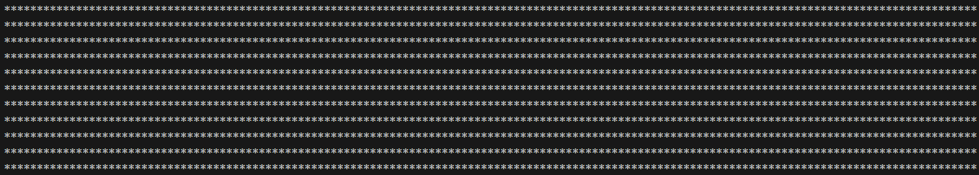

: the loop will not stop, because it will not find 5

**Question 2.2**

1. Pay attention to the outer loop. If in the for syntax, the initialization of iOuter = 1 is changed to iOuter = 0, what is the result? Why is that?

2. Restore the original program where iOuter = 1 initialized. Then notice the inner loop, If in the syntax for, the initialization I = 1 is changed to I = 0, what is the result? Why is that?

3. So, what is the difference in usefulness between the outer loop and the loop inside?

4. Why is it necessary to add the Syntax System.out.println(); under the inner loop? What are the consequences if the syntax is removed?

5. Please commit and push to your repository.

**Answer 2.2**

1.  : The number of rows increases to 6

2. 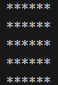 : The column will increase by 1, to 6 stars

### 3. A. Loop Luar (Outer Loop)

* Loop luar **mengontrol baris** dalam pola.
* Setiap iterasi dari loop luar merepresentasikan satu baris dalam output.
* Pada setiap iterasi loop luar, kita memulai satu baris baru, lalu loop dalam akan menambahkan elemen-elemen yang diperlukan dalam baris tersebut.
* Misalnya, untuk nilai N=5N = 5N=5, loop luar akan berjalan sebanyak 5 kali untuk menghasilkan 5 baris dalam output.

**B. Loop Dalam (Inner Loop)**

* Loop dalam **mengontrol kolom** dalam setiap baris.
* Setiap iterasi dari loop dalam merepresentasikan satu kolom (atau satu elemen) dalam baris yang sedang dibentuk oleh loop luar.
* Loop dalam akan menambahkan angka atau karakter yang diperlukan di setiap kolom dalam satu baris yang dihasilkan oleh loop luar.
* Misalnya, jika nilai N = 5, loop dalam akan berjalan 5 kali untuk setiap baris, sehingga setiap baris akan memiliki 5 elemen atau angka.

4. The program will not create a new line

5. <https://github.com/muchnabil/daspro-jobsheet8>

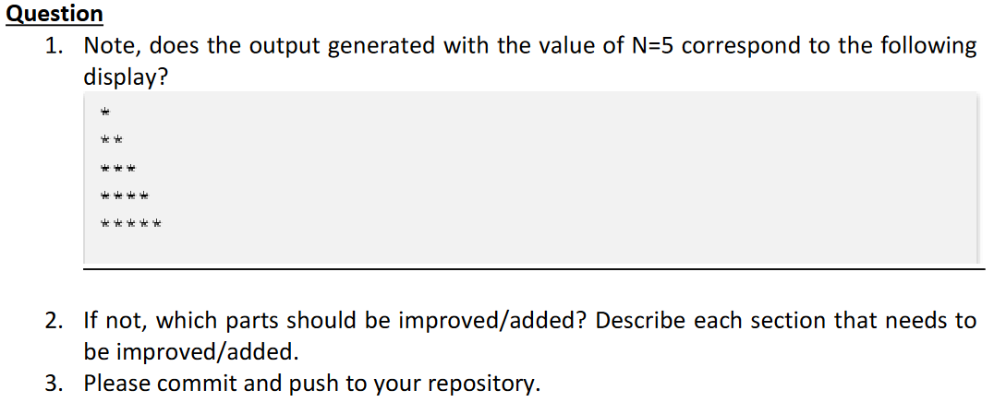

**Answer 2.3**

1. 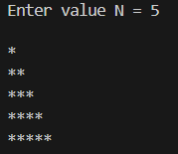 : Yes

2. 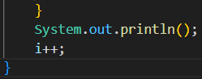 : If not, then you must do the following as shown in the next figure.

3. <https://github.com/muchnabil/daspro-jobsheet8>

**Experiment 2.4**

